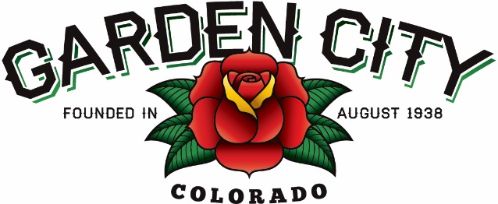
Board of Trustees Regular Meeting Agenda
April 01, 2025 at 5:30 PM
Town Hall - 621 27th Street Road, Garden City, CO 80631
The Board will consider and may act on the following items:
- Call to Order
- Roll Call
- Consent Agenda
  - Approve Minutes from March 18, 2025 Regular Meeting
  - Approve Bills Paid
  - Approve Bills to be Paid
  - Approve Hauser Architects invoice in the amount of $10,934.00
- Public Not on the Agenda Invited to be Heard
- Liquor
  - Approve Ron-Lee-Von LLC DBA White Horse Inn LLC Festival Permit Application for Bootleggin' Days 2025
  - Permission Letter
- Consider D&B Lockworks Estimate in the amount of $3,161.55
  - Estimate
- TV donation options
- Ordinance Updates
- Discussion regarding Community Center Chairs
- National Night Out updates
  - National Night Out Letter
  - National Night Out Flyer
- Staff Reports
  - Town Administrator
  - Police Chief
  - Public Works Director
  - Town Attorney
- Other Board Issues
- Announcements
  - The Easter Event is Saturday, April 12th at 10:00am
  - Cheryl will be out of the office from April 14th-18th
- Adjourn

