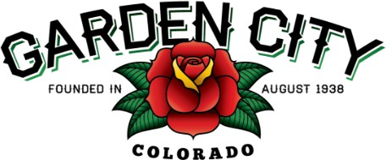

Board of Trustees Regular Meeting Agenda
June 17, 2025 at 5:30 PM
Town Hall - 621 27th Street Road, Garden City, CO 80631

The Board will consider and may act on the following items:
- Call to Order
- Roll Call
- Swear in Timothy Costello as Buildings and Grounds Supervisor
- Consent Agenda
  - Approve Minutes from June 3, 2025 Regular Meeting
  - Approve Financial Reports for May 2025
  - Approve Bills Paid
  - Approve Bills to be Paid
  - Approve Build West invoice in the amount of $30,000.00.
- Public Not on the Agenda Invited to be Heard
- Grants
  - Consider El Rodeo Night Club LLC Commercial Revitalization Grant Application
- Marijuana
  - Smoke Holdco LLC DBA Star Buds Medical Marijuana Facility License Renewal ML- 2515-25
- Greeley Intergovernmental Agreement for Street Maintenance
  - Approve Greeley Intergovernmental Agreement for Street Maintenance
- Franchise Agreement
  - Cable Television Franchise Agreement by and between Town of Garden City, Colorado and Comcast of Colorado IX, LLC
- Staff Reports
  - Town Administrator
  - Police Chief
  - Town Attorney
- Consider Letters of Interest for The Garden City Board of Trustees vacancy
  - Letter of Interest from Shanice Meza
  - Letter of Interest from Jasmine Marquez
  - Swear in appointed trustee
- Other Board Issues
- Announcements
  - The CML Conference is June 23rd through the 26th
- Adjourn

