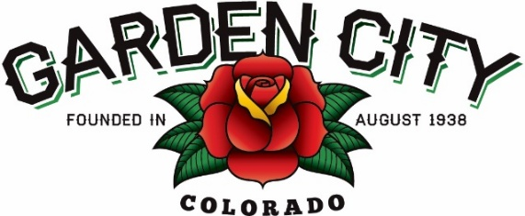
Board of Trustees Regular Meeting Agenda
April 15, 2025 at 5:30 PM
Town Hall - 621 27th Street Road, Garden City, CO 80631
The Board will consider and may act on the following items:
- Call to Order
- Roll Call
- Consent Agenda
  - Approve Minutes from April 1, 2025 Regular Meeting
  - Approve Month End Financial Report for March 2025
  - Approve Bills Paid
  - Approve Bills to be Paid
  - Approve JustFOIA invoice in the amount of $5,123.25
- Public Not on the Agenda Invited to be Heard
- Liquor
  - Approve Special Events Permit for Picasso and Wine on May 17th, 2025
  - Picasso and Wine Permission Letter
- Approve donation of the Community Center chairs
- JustFOIA Contracts
  - Approve JustFOIA Master Services Agreement
  - Approve the JustFOIA Addendum 1
- Storm drain cleaning
  - Consider DES Pipeline Maintenance LLC estimate in the amount of $15,475.00
- 27th Street drainage issue
  - TSC.Inc Proposal
- Consider Evans Area Chamber of Commerce renewal
  - Evans Chamber Letter
- Staff Reports
  - Town Administrator
  - Police Chief
  - Public Works Director
  - Town Attorney
- Executive Session regarding a personnel issue
- Other Board Issues
- Announcements
  - Cheryl is out this week and will be back in the office on Monday, April 21st
  - Lindsay will be out of the office April 28th-May 1st
  - Spring Clean-Up Days is May 2nd, 3rd, and 4th from 8am-5pm
- Adjourn

