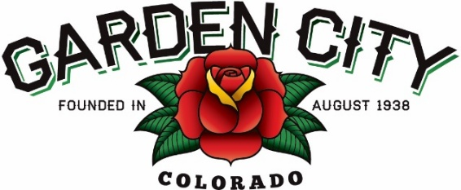
Board of Trustees Regular Meeting Agenda
January 21, 2025 at 5:30 PM
Town Hall - 621 27th Street Road, Garden City, CO 80631
The Board will consider and may act on the following items:
- Call to Order
- Roll Call
- Consent Agenda
  - Approve Minutes from January 7, 2025 Regular Meeting
  - Approve Treasurer’s Report for December 2024
  - Approve Bills Paid
  - Approve Bills to be Paid
  - Approve Mde, Inc invoice in the amount of $4,042.00
  - Approve Hauser Architects invoice in the amount of $7,735.00
- Public Not on the Agenda Invited to be Heard
- Marijuana
  - Smoke Holdco LLC DBA Star Buds 2502 8th Ave RL-2502-25 Retail Marijuana License Renewal
- Liquor
  - Wing Shack Enterprises Inc DBA 8th Avenue Wing Shack Hotel & Restaurant Liquor License Renewal
- Grants
  - Approve Jerry Griego progress payment in the amount of $532.72 for his Residential Revitalization Grant
- Community Center
  - Approve new deposit rates without the use of alcohol
  - Approve alcohol allowance in the Community Center with deposit and rate amount
  - Approve bartender service policy for Community Center rentals with alcohol
- Approve First Farm Bank access to Maria Cardenas, Finance Clerk
  - Approval Letter
- Approve Air Solutions quote in the amount of $1,185.00
  - Approve Air Solutions quote in the amount of $1,185.00
- Fun Under the Sun Event
  - Fun Productions quote for kids event
  - Approve quote from Little Angels Pony and Pals for petting zoo
- Ordinances
  - Adopt Ordinance 03-2025 An Ordinance Amending Article 2 - Alcoholic Beverages, Division 2 - Licenses, Chapter 6 - Business Licenses And Regulations Of The Garden City Municipal Code Regarding Renewal Licenses
- Staff Reports
  - Town Administrator
  - Police Chief
  - Public Works Director
  - Town Attorney
- Other Board Issues
- Announcements
- Adjourn

